**Eagle Tutorial**

## Objective

In this project, we will learn about graphical representation of circuits called schematics. A short tutorial will be presented to introduce the students to basics of schematic capture.

## Overview

When designing a circuit that is to be eventually turned into a circuit board, it is much more convenient and easier to understand when the design is represented graphically. For example, for a simple LED circuit with a current limiting resistor, one might have to create the following verbal instructions:

* The design used a 9V battery, 1K resistor R1, and an LED D1
* Connect the positive side of the battery to one side of R1
* The other side of R1 is connected to the positive lead of D1
* The negative side of D1 is then connect back to the negative side of the battery
* No other connections exists in this schematic

As one can see, a verbal description can easily become cumbersome and very complex for even a slightly more complicated circuit.

Graphical representations, called schematics, can convey the same information in a much more succinct way. For the circuit above, for example, the following schematic captures the information simply and without any ambiguity.

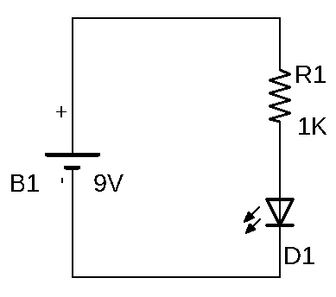

Figure - LED Circuit Schematic

One of the popular and freely available schematic capture programs is Eagle by Autodesk. In the rest of this worksheet, we will go through a simple tutorial of Eagle commands to capture the schematics for the design of your choosing.

## Procedure

The following steps will guide you through capturing the schematic for the Blinky circuit shown below. The steps for capturing the schematic of your own choosing will be similar to the ones outlined below.

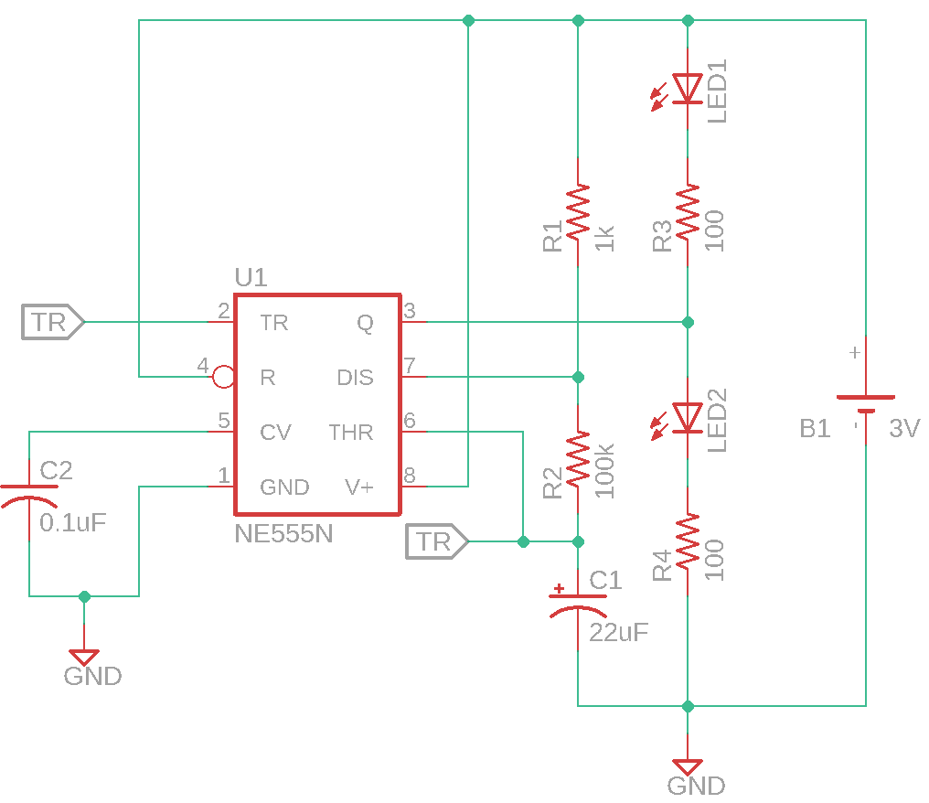

Figure - Blinky Schematic

1. On Github site, fork <https://github.com/League-EE/EE-Workshop> to your account and then clone it on your desktop.
2. Open the Blinky schematic in “EE-Workshop/Lesson 4” folder.
   1. This will launch the Eagle schematic capture program and load the Blinky schematic.
   2. The schematic has the battery symbol already place for you. You will go through placing the rest of the components for your design.
3. Placing parts
   1. To place a part, click on the “Add Part” icon , or choose “Add…” from the “Edit” menu.
   2. The following “ADD” window will open displaying the available libraries to choose parts from.  
        
      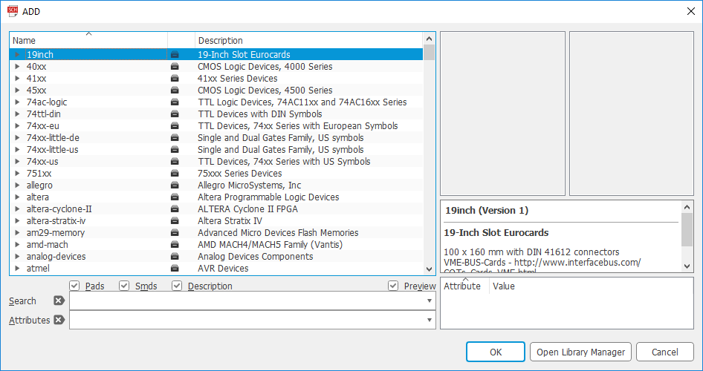
   3. In the “Search” field type “NE555*”. This will bring up all the parts starting with “NE555”.
   4. Under the “linear” library, click on *555 folder, select NE555N and click “OK”.  
        
      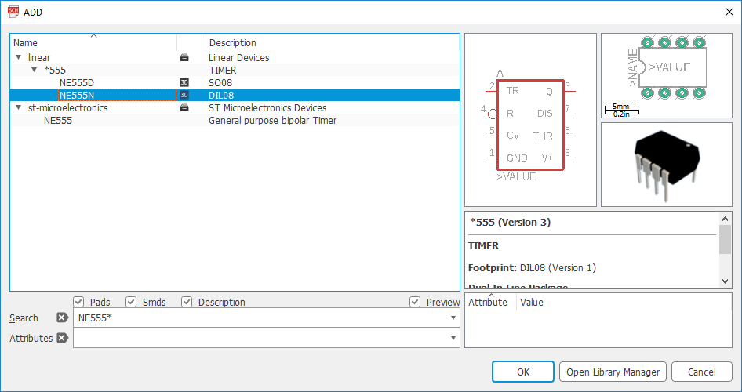
   5. This will select the NE555N part for you and allows you to place it in your schematic.
   6. Place the part in your schematic as seen below.  
        
      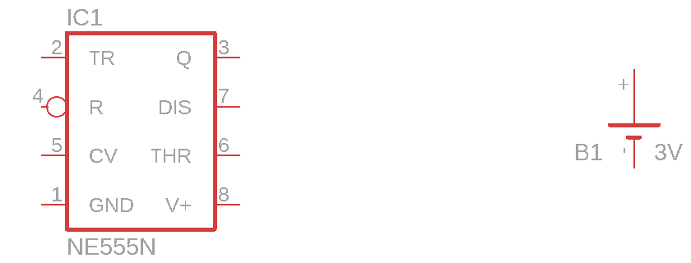  
      You will notice that after placing the part, the tool will automatically show another part of the same kind ready to be placed. This will be very useful when you are placing multiple, for example, resistors. For this part, press “Esc” to end placement of the NE555N part. The tool will return to the “ADD” window.
   7. Clear the search by clicking on the “x” next to “Search”.
   8. This time we will search for a resistor to place by browsing through the libraries
      1. Scroll down to the “rcl” library and click on the small triangle next to it to open it.
      2. Scroll down to “R-US_” library and click to open it.
      3. Select the part “R-US_0309/12” and click OK to select it for placement.
   9. You will notice that resistor symbol is in a horizontal configuration. Right click to rotate the symbol by 90o.
   10. Place as many instances of the resistor as you need on your schematic by left clicking the mouse at the desired location. For the Blinky circuit, your schematic should look like the one below.  
         
       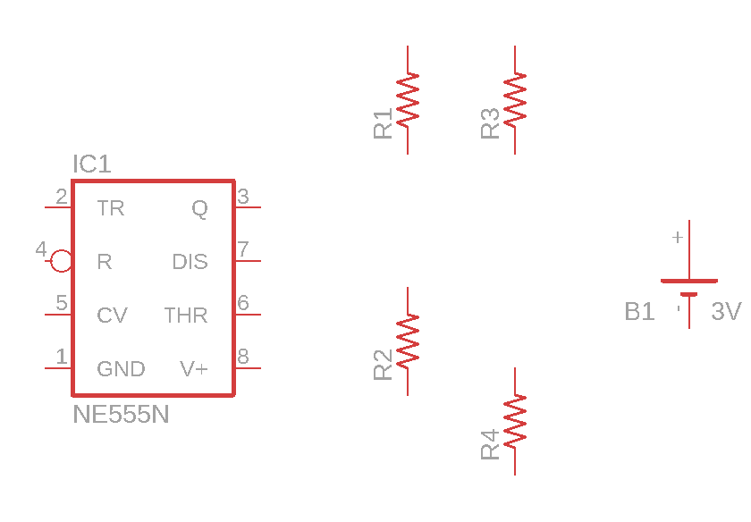
   11. Place the rest of the parts in your schematic following the steps outlined above. After placing all your parts, in case of the Blinky circuit, your final schematic should look similar to the one in Figure 2.
4. Setting Values
   1. In order to change the value of a part in your schematic, you can either choose the “Value…” item from the “Edit” menu, click on the “Value” icon , or right click on a part and select “Value” from the dropdown menu.
   2. To change the value of R1, click on the “Value” icon and then click on R1.
      1. This will open the “Value” window where you can enter the desired value:  
           
         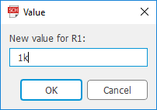
      2. Enter the value 1k, and click on OK.
   3. Go ahead and change the values for all the parts in your schematic to those specified in .
5. Connecting the parts
   1. In order to connect the parts on the schematic with nets, either select “Net” from the “Draw” menu or click on the “Net” icon .
   2. To connect a net to a part, click on the lead that you’d like to connect a net to. This will create a connection to the lead that was just clicked on. (In our example below, we are connecting a net from pin 5 of U1 to the top lead of C2.)  
        
      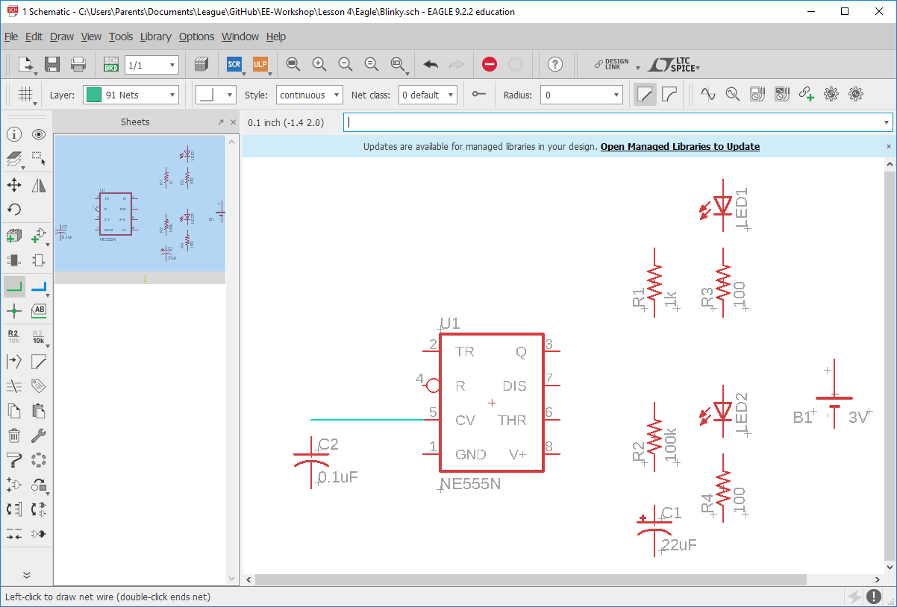
   3. Drag the other end of the net to any location on the schematic and click again. This will create a junction point where you can move the net in the direction perpendicular to the original direction.  
        
      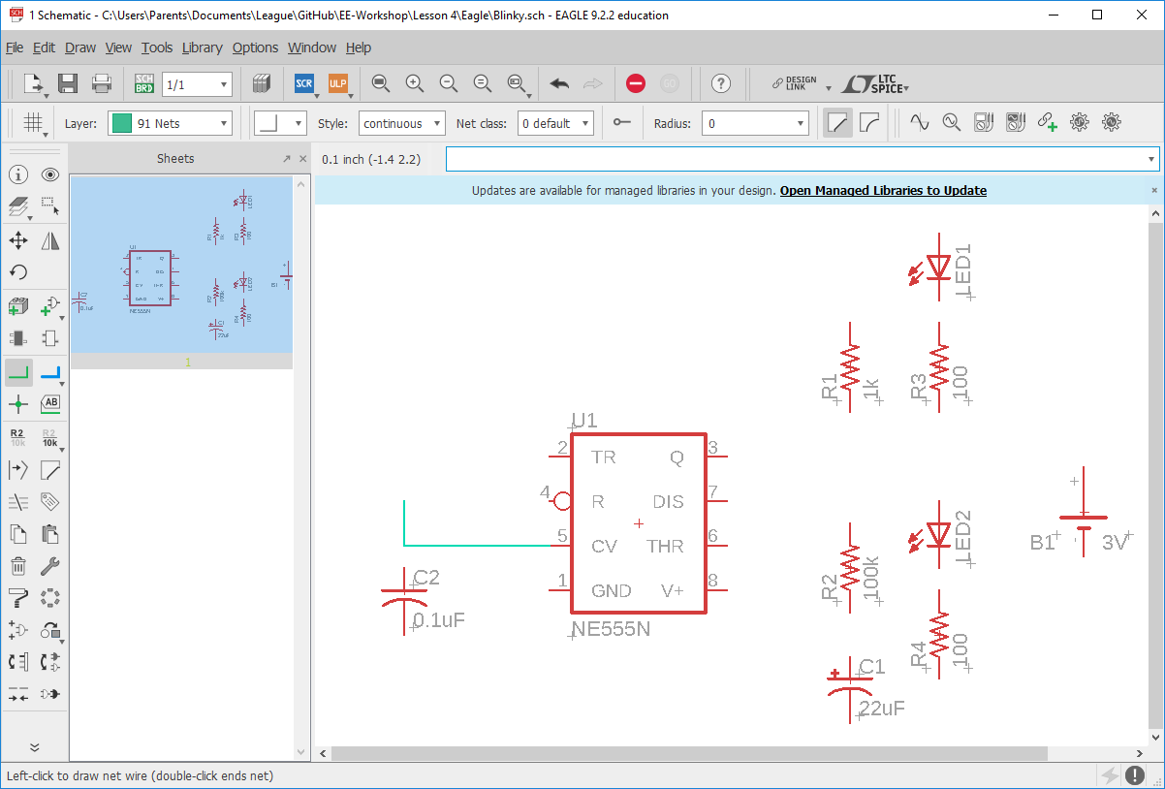
   4. Once you have dragged the net to the part that it needs to be connected to, click on the lead that the net should be terminated on. This will end the current net on the lead just clicked on.  
        
      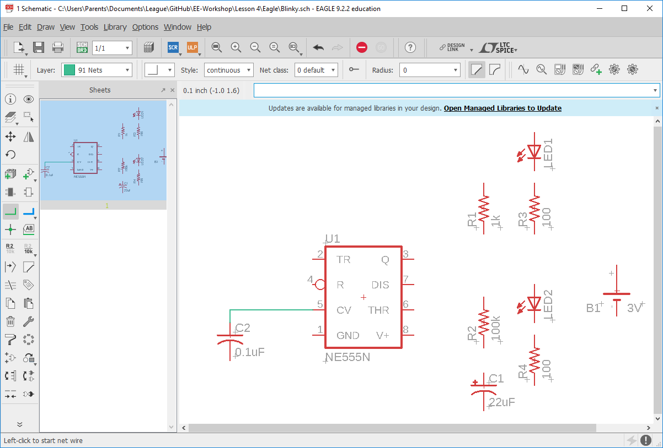
   5. Complete connecting all the nets for your schematic. For the Blinky circuit, the final schematic should look similar to the one in Figure 2.
6. Adding GND
   1. Adding a ground to your schematic is the same as adding a part.
   2. Click on the “Add Part” icon and enter “GND” in the search field.
   3. Select the appropriate symbol and place it on your schematic.
   4. Connect the ground to the appropriate nets as indicated in your design.
   5. When connecting ground, the tool will ask if you are intending to merge the current net name for the net you have selected with “GND”. (See the example below.)   
        
      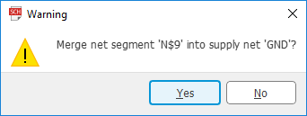
   6. Click “Yes” to complete the process.
7. Adding Labels and Cross References (Xref)
   1. A “Cross Reference” helps with connection of nets on different pages. Even though our schematic has only one page, we will add a cross reference to show connectivity between two nets on the same page.
   2. To add a cross reference, first either select “Label” from the Draw menu or click on the “Label” icon .
      1. Click on the “Xref On” icon  on the ribbon above the schematic. This will turn on the cross reference graphics for the net names (labels).
      2. Click on the net that you’d like to add a label to. For our example, we click on the “TR” pin of “U1”.
      3. This will display the current name of the net that you can drag around and place on the schematic.
      4. Place the Xref at the end of the net as shown in the example below. (If you need to rotate the Xref, repeatedly right click on the mouse.)  
           
         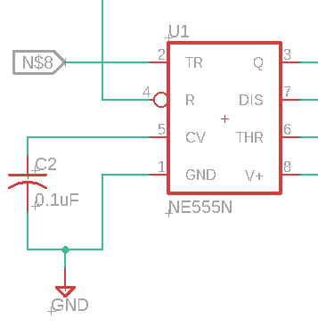
      5. Right click on the “+” reference point of the Xref just placed and click on “Name” from the dropdown menu. This will open a dialogue window that will allow you to change the net name. Change it to “TR” and click “OK”.
      6. Now the Xref should display “TR” as shown below.  
           
         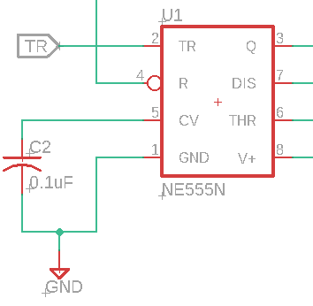
      7. Add another cross reference with the same name “TR” to the net connected between R2 and C1 as shown below.  
           
         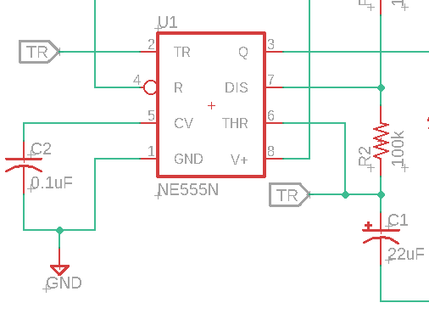
      8. These two nets are not treated as the same net by the tool.
      9. Add any other Xref indicated in your design.

Your final schematic should look similar to the one for you design. In the case of the Blinky design, it should look similar to the one given below.



Make sure you commit and push your final files to github.